**Online News Proposal**

**SID:540352670**

**Headline: Shock! 315 Gala exposed sanitary pads scandal in China: Waste turned into feminine products**

1. **lead**

Can you imagine that the sanitary pads you use monthly are from a workshop with a nauseating environment full of waste? It is not alarmist talk. The annually held 315 Gala exposed a sinister fact to Chinese consumers.

1. **Core content**

**Facts reported on 315 Gala**

[315 Gala](https://www.scmp.com/news/china/article/3302887/chinas-annual-315-gala-uncovers-illegal-supply-chain-sanitary-pads-made-waste) is an event held on March 15th every year, specially designed to expose matters of consumer rights violations in social life. It is broadcast through CCTV, China Central Television. During the Gala, journalists exposed an astonishing illegal supply chain of sanitary pads. [Numerous famous companies and local regulators](https://www.globaltimes.cn/page/202503/1330173.shtml) participated in investigating and addressing the issue.

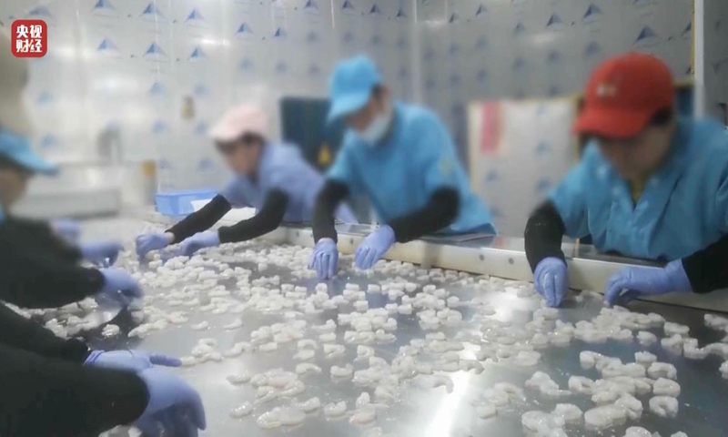

Photo: CCTV

Some illegal companies are accused of using waste as raw material for sanitary pads, severely threatening consumers’’ health. #Waste sanitary pads and other related topics rosed attention on Chinese social media.

**How does the illegal supply chain work?**

According to the [investigation](https://www.scmp.com/news/china/article/3302887/chinas-annual-315-gala-uncovers-illegal-supply-chain-sanitary-pads-made-waste), certain companies recycled medical or industrial wastes, and cotton with lesser quality. After an elaborate process, these wastes could be remade into seemingly qualified products. Then, via e-commerce platforms, low-end wholesale markets and some offline supermarkets, these poorly qualified products emerged in the market with inexpensive prices to draw consumers.

**Consumer trust crisis**

Prior to the Gala, [the leading manufactures](https://www.bbc.co.uk/news/articles/cev9ry341dyo) of sanitary pads in China market apologized for the size of their products. Hence, consumers have grown increasingly cautious when choosing sanitary pads ever since.

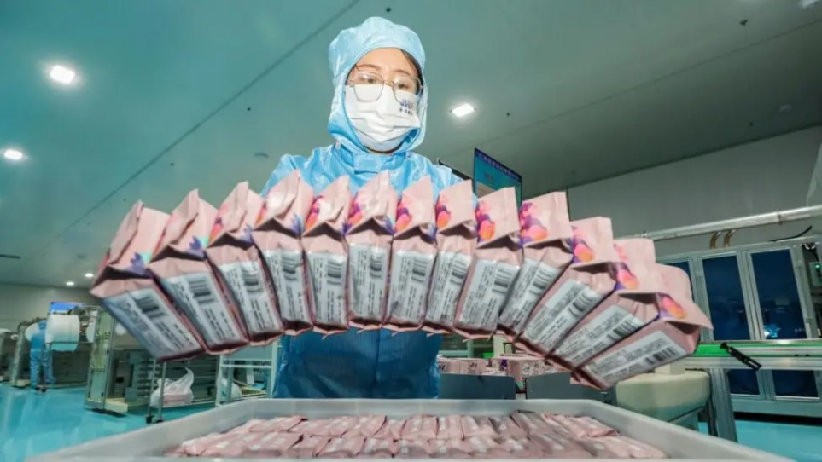

Photo: Getty Images

**Health risks and consumer rights protection predicament**

[Chinese authorities](https://www.bbc.com/news/world-asia-pacific-37788670) warn that using these products may lead to serious health problems, especially female reproductive health. They might contain bacterium and poisonous substances like heavy metals. Long-term usage is likely to bring forth infection and allergy. On the other hand, experts on consumer rights protection indicate that although current regulations may have restrictions on sanitary products, there are still loopholes. It is of great complexity that consumers defend their rights.

**Sanitary pad scandal sparking discussion over gender inequality**

Although Australian productive lines remain safe, partial females are compelled to lean on lesser products, which resonates internationally to Chinese females using contaminated sanitary pads.

**Conclusion and sublimation**

When the quality issue of a mere piece of sanitary pad endangers females’ health, it becomes greater than a consumer matter, rather one of global [gender equality](https://www.abc.net.au/news/2024-12-05/sanitary-pad-scandal-sparks-outrage-in-china/104674990?utm_campaign=abc_news_web&utm_content=link&utm_medium=content_shared&utm_source=abc_news_web). The illegal productions in Chinese factories expose not only a loophole in the supply chain, but a neglect to female health. A lesser product threatens every woman’s basic right to master over her own body. Despite the fact that the Australian government may process further strict supervision, only would not the female have to be sacrificed for the costs when the equality will be achieved.

**Suitable media for publication**

The topic plans to be published on the health section on ABC NEWS Online. In order for Australian readers’ satisfaction, the language used will be short and precise.

**Al statement**

I used ChatGPT to help me organize the structure and form ideas, but I acknowledge all content is written by me, and I take full responsibility for any inaccuracy in the work.

**Reference**

1. Branigan, T. (2016, October 27). China's period shame: The women fighting to break the silence. *BBC News*. <https://www.bbc.co.uk/news/world-asia-pacific-37788670>​
2. Ewe, K. (2024, November 28). Chinese companies apologise for 'shrunken' sanitary pads. *BBC News*. <https://www.bbc.co.uk/news/articles/cev9ry341dyo>​
3. Zhou, J. (2024, December 5). Sanitary pad scandal sparks outrage over gender inequality in China. *ABC News*. <https://www.abc.net.au/news/2024-12-05/sanitary-pad-scandal-sparks-outrage-in-china/104674990>
4. Feng, F. (2025, March 16). China's '3.15' consumer rights gala puts the spotlight on sanitary products, food safety, and digital economy. *Global Times*. <https://www.globaltimes.cn/page/202503/1330173.shtml>
5. Wang, C. Q. (2025, March 18). *China’s annual 315 Gala uncovers illegal supply chain for sanitary pads made from waste*. South China Morning Post. <https://www.scmp.com/news/china/article/3302887/chinas-annual-315-gala-uncovers-illegal-supply-chain-sanitary-pads-made-waste>​